Chapter 4: System Analysis and Design

4.1 Software Development Methodology
In this project, the Agile Scrum Methodology was adopted. This approach is highly suitable for AI-based projects where requirements may evolve, and iterative testing is crucial. The development process was divided into short iterations called "Sprints":
- Planning Phase: Defining the scope (Dental Diagnosis) and gathering the dataset.
- Development Phase: Building the AI models (YOLO & ResNet) and the Backend API.
- Testing & Refinement: Evaluating model accuracy and integrating the Generative AI (Gemini) for better reporting.
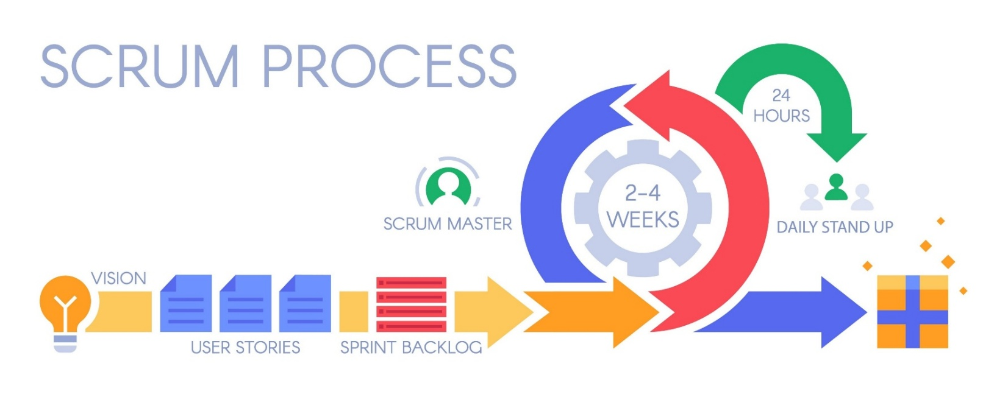
- Deployment: Integrating all components into a functional system.
Figure 4.1: Agile Scrum Methodology Cycle

4.2 Requirement Analysis
The requirement analysis phase focuses on defining the system's capabilities and constraints. The requirements are categorized into Functional Requirements (what the system should do) and Non-Functional Requirements (how the system should perform).

4.2.1 Functional Requirements
These are the core features that allow the user to interact with the system effectively:
- User Authentication: The system must allow patients to register using personal details and log in securely to access their private data.
- Image Upload & Validation: The user should be able to capture or upload intra-oral images. The system must validate the image format and quality before processing.
- AI Diagnosis: The backend must trigger the AI model to analyze the uploaded image and detect dental diseases (e.g., caries, gingivitis).
- Report Generation: The system must utilize Generative AI to produce a comprehensive, human-readable medical report based on the analysis.
- Interactive Chat: A conversational interface must be provided, allowing users to ask follow-up questions about their diagnosis.
- Medical History: The system should store and display a history of the user's previous diagnoses and reports.

4.2.2 Non-Functional Requirements
These requirements ensure the quality and reliability of the system:
- Performance: The AI analysis and report generation should be completed within a reasonable time frame (under 10-15 seconds) to ensure a smooth user experience.
- Security: Patient data and medical records must be encrypted and stored securely, ensuring privacy and confidentiality.
- Scalability: The system architecture should be capable of handling multiple concurrent requests without crashing.
- Usability: The mobile application interface must be intuitive and user-friendly for patients of different age groups.

4.3 System Architecture
The proposed system follows a Multi-Tier Architecture approach, designed to ensure scalability, modularity, and maintainability. The system is composed of four main layers:
1. Presentation Layer (Client Side): This is the user interface (Mobile Application) where patients interact with the system. It handles image capturing, uploading, and displaying the diagnosis results and chat responses.
2. Application Logic Layer (Backend API): Built using Node.js and Express.js, this layer acts as the central controller. It manages API endpoints (RESTful API), handles authentication, validates requests, and orchestrates communication between the database and the AI engine.
3. AI Processing Layer (The Core Engine): Since AI tasks require heavy computation and specific libraries, a separate Python environment is used. This layer includes:
- Computer Vision Models: ResNet50 for classification and YOLOv8 for object detection.
- Generative NLP Engine: Integration with Google Gemini 1.5 Flash for generating medical reports and handling chatbot context.
- Process Management: Node.js communicates with this layer using child processes (spawn), ensuring efficient data exchange.

4. Data Layer (Database): MongoDB (NoSQL database) is utilized to store unstructured and semi-structured data, including:
- Patient profiles.
- Diagnosis results (JSON format).
- Chat history sessions.
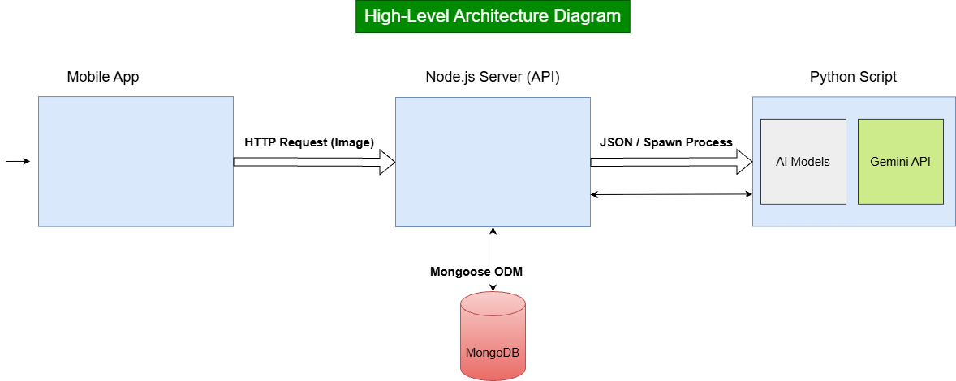
Figure 4.2: High-Level System Architecture

4.4 System Design
4.4.1 Database Design (ERD)
The database schema is designed using MongoDB (NoSQL) to accommodate the flexible nature of medical data, particularly the JSON-based AI analysis results. The Entity-Relationship Diagram (ERD) in Figure 4.3 illustrates the logical structure of the database, highlighting the four main entities and their relationships:
1. Entities Description:
- Patient: The core entity representing the user. It stores personal details (name, age, gender) and contact information. A composite attribute is used for the address to ensure detailed location data, and a multi-valued attribute is used for medical history to record chronic conditions.
- Diagnosis: Represents a single "check-up" event. It links the uploaded dental image with the AI's detection results (bounding boxes and class labels).
- MedicalReport: Stores the generative AI's output. It contains the detailed advice, urgency level, and action plan generated by the Large Language Model (Gemini) based on the diagnosis.
- ChatSession: Records the interactive conversation history between the patient and the AI assistant regarding a specific diagnosis.

2. Relationships & Cardinality:
- Patient ↔ Diagnosis (1:N): A single patient can perform multiple diagnosis requests over time (One-to-Many). However, each diagnosis record must belong to exactly one patient.
- Diagnosis ↔ MedicalReport (1:1): Each diagnosis process triggers the generation of exactly one unique medical report (One-to-One). This strict relationship ensures that every analysis has a corresponding textual explanation.
- Diagnosis ↔ ChatSession (1:1): For every diagnosis, a dedicated chat session context is initialized (One-to-One). This allows the patient to ask follow-up questions specific to that particular case without mixing contexts.
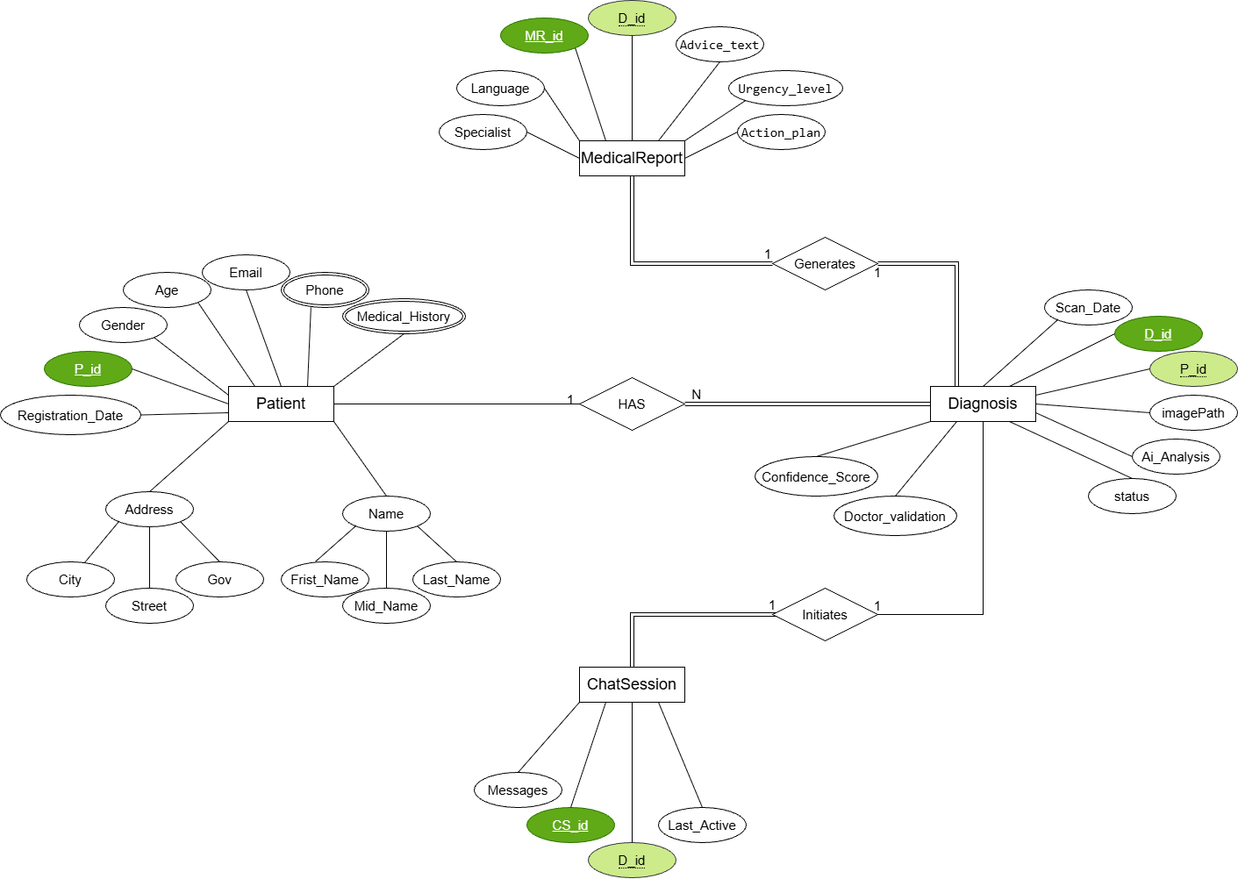
Figure 4.3: Entity Relationship Diagram (ERD)

4.4.2 System Behavior (UML Diagrams)
To visualize the system's interactions and workflow, Unified Modeling Language (UML) diagrams were created.
A. Sequence Diagram
The Sequence Diagram in Figure 4.4 details the flow of operations for the core diagnosis feature. The process follows these steps:
- Initiation: The patient captures an image via the mobile app, which sends a secure HTTP POST request to the Node.js server.
- Orchestration: The Node.js server validates the request and triggers a child process using spawn to execute the Python script, passing the image path as an argument.
- AI Analysis: The Python script loads the computer vision models (YOLO/ResNet) to detect dental issues.
- Generative Reasoning: The Python script constructs a prompt based on the detection results and sends it to the Google Gemini API to generate a human-like medical report.
- Data Aggregation: The Python script combines the vision analysis and the generated text into a JSON object and prints it to the standard output, which is captured by the Node.js server.
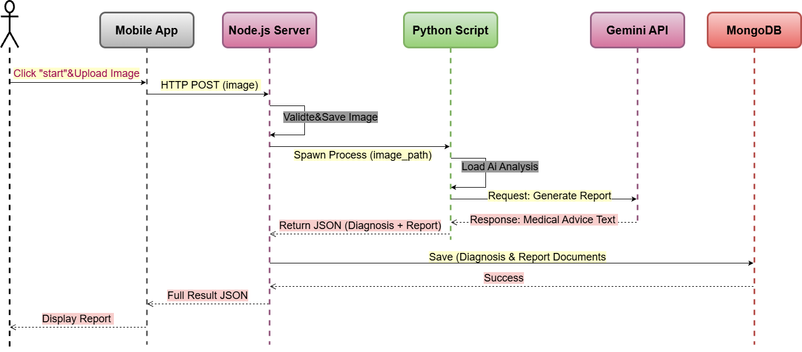
- Persistence & Response: The Node.js server saves diagnosis and report to MongoDB and finally returns the complete result to the mobile app for display.

Figure 4.4: Sequence Diagram for Diagnosis Process

B. Use Case Diagram
The Use Case Diagram (Figure 4.5) depicts the interactions between the primary actor (The Patient) and the system. The core functionalities available to the user are:
- Register / Login: The entry point where users create an account or authenticate to access the system securely.
- Upload Dental Image: The primary function where the patient captures or selects an intra-oral image for analysis.
- View Diagnosis & Medical Report: After processing, the user can view the AI-generated results, including disease detection (bounding boxes) and the detailed textual report.
- Chat with AI Assistant: This feature allows the user to engage in a context-aware conversation with the Generative AI to ask follow-up questions regarding their specific diagnosis.
- View Medical History: The user can access a log of their previous diagnoses and reports tracked by the system.
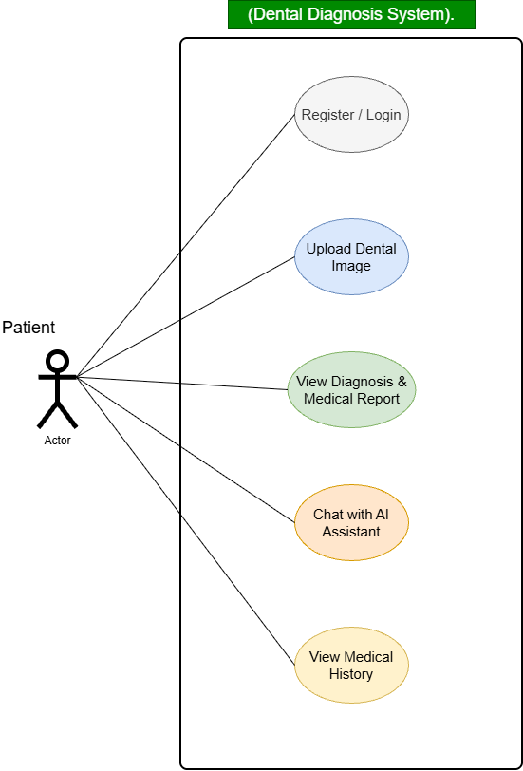

Figure 4.5: Use Case Diagram
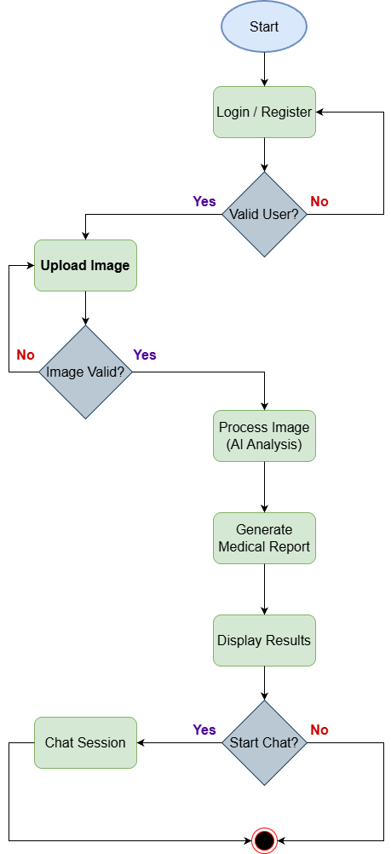
C. Activity Diagram
The Activity Diagram (Figure 4.6) illustrates the operational workflow of the system. It demonstrates the logical sequence starting from user authentication, proceeding to image validation and AI processing, and concluding with result presentation and optional interactive chat. It handles exception scenarios such as invalid login credentials or unclear image uploads by routing the flow back to the appropriate input stage.

Figure 4.6: Activity Diagram

